Article title
Author Name¹, Author Name² and Author Name^{1,2}
¹ Department One, Institution One, City One, Country One
² Department Two, Institution Two, City Two, Country Two

E-mail: xxx@xxx.xx

Received xxxxxx
Accepted for publication xxxxxx
Published xxxxxx
Abstract
The abstract should contain maximum of 300 words.

Keywords: max 5 keywords

1. Section heading

Black hole is a region of spacetime exhibiting such strong gravitational effects that nothing—not even particles and electromagnetic radiation such as light—can escape from inside it.[1] The theory of general relativity predicts that a sufficiently compact mass can deform spacetime to form a black hole.[2][3] The boundary of the region from which no escape is possible is called the event horizon. Although the event horizon has an enormous effect on the fate and circumstances of an object crossing it, no locally detectable features appear to be observed.[4] In many ways a black hole acts like an ideal black body, as it reflects no light.[5][6] Moreover, quantum field theory in curved spacetime predicts that event horizons emit Hawking radiation, with the same spectrum as a black body of a temperature inversely proportional to its mass. This temperature is on the order of billionths of a kelvin for black holes of stellar mass, making it essentially impossible to observe.

  - Subsection heading

Objects whose gravitational fields are too strong for light to escape were first considered in the 18th century by John Michell and Pierre-Simon Laplace.[7] The first modern solution of general relativity that would characterize a black hole was found by Karl Schwarzschild in 1916, although its interpretation as a region of space from which nothing can escape was first published by David Finkelstein in 1958. Black holes were long considered a mathematical curiosity; it was during the 1960s that theoretical work showed they were a generic prediction of general relativity. The discovery of neutron stars by Jocelyn Bell Burnell

Table 1. Example of a Table. Table should be inserted inside the text which will be in single column
Column 1 | Column 2 | Column 3 | Column 4 | Column 5 | Column 6 | Column 7 | Column 8

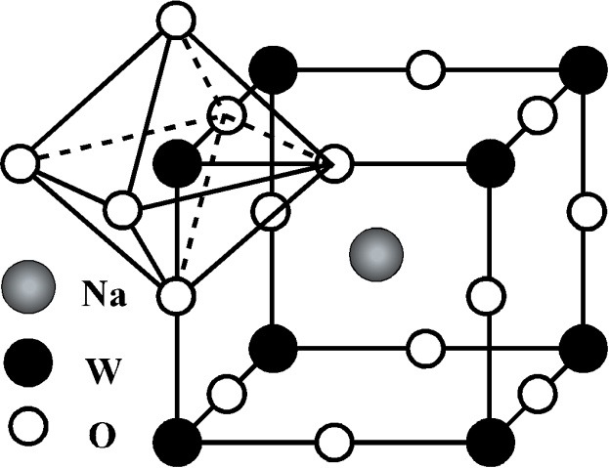
in 1967 sparked interest in gravitationally collapsed compact objects as a possible astrophysical reality.
    - Subsubsection heading.

Black holes of stellar mass are expected to form when very massive stars collapse at the end of their life cycle. After a black hole has formed, it can continue to grow by absorbing mass from its surroundings. By absorbing other stars and merging with other black holes, supermassive black holes of millions of solar masses (M☉) may form. There is general consensus that supermassive black holes exist in the centers of most galaxies.
FIG. 1. Cubic crystal structure of NaWO₃ showing corner sharing WO₆ octahedra.
Despite its invisible interior, the presence of a black hole can be inferred through its interaction
with other matter and with electromagnetic radiation such as visible light. Matter that falls onto a black hole can form an external accretion disk heated by friction, forming some of the

brightest objects in the universe. If there are other stars orbiting a black hole, their orbits can be used to determine the black hole's mass and location. Such observations can be used to exclude possible alternatives such as neutron stars. In this way, astronomers have identified numerous stellar black

hole candidates in binary systems, and established that the radio source known as Sagittarius A*, at the core of the Milky Way galaxy, contains a supermassive black hole of about 4.3 million solar masses.

Acknowledgements
References
- A Surname, B Surname and C Surname, Journal Name 37 074203 (2015)

- A Surname, B Surname and C Surname, Journal Name 37 231 (2018)

